Alkane | Kugel-/Stabmodell | Molekülformel | LEWIS-Formel | Schmelztemperatur in °C | Siedetemperatur in °C | Dichte in $\frac{g}{{cm}^{3}}$
Methan | 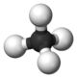 | CH₄ | 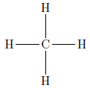 | -182 | -161 | 0,466
Ethan | 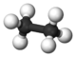 | C₂H₆ | 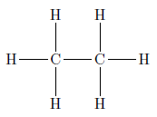 | -183 | -183 | 0,572
Propan | 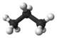 | C₃H₈ | 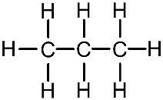 | -189,7 | -42 | 0,585
Pentan | 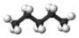 | C₅H₁₂ | 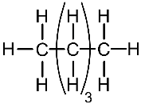 | -130 | 36 | 0,626
Hexan | 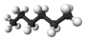 | C₆H₁₄ | 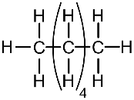 | -95 | 69 | 0,659
Heptan | 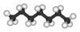 | C₇H₁₆ | 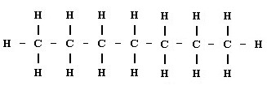 | -91 | 98 | 0,684
Heptadecan | 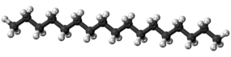 | C₁₂H₃₆ |  | 22 | 302 | 0,778

